Nagwa Aboelftouh

4221150

C1

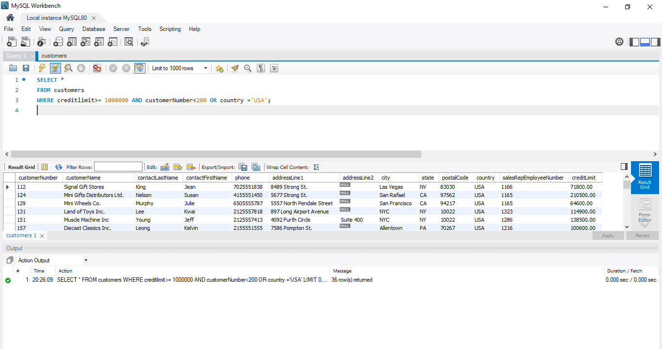Get all customers with creditLimit more than or equal to 1000000 and customerNumber less than 200 or country is USA.

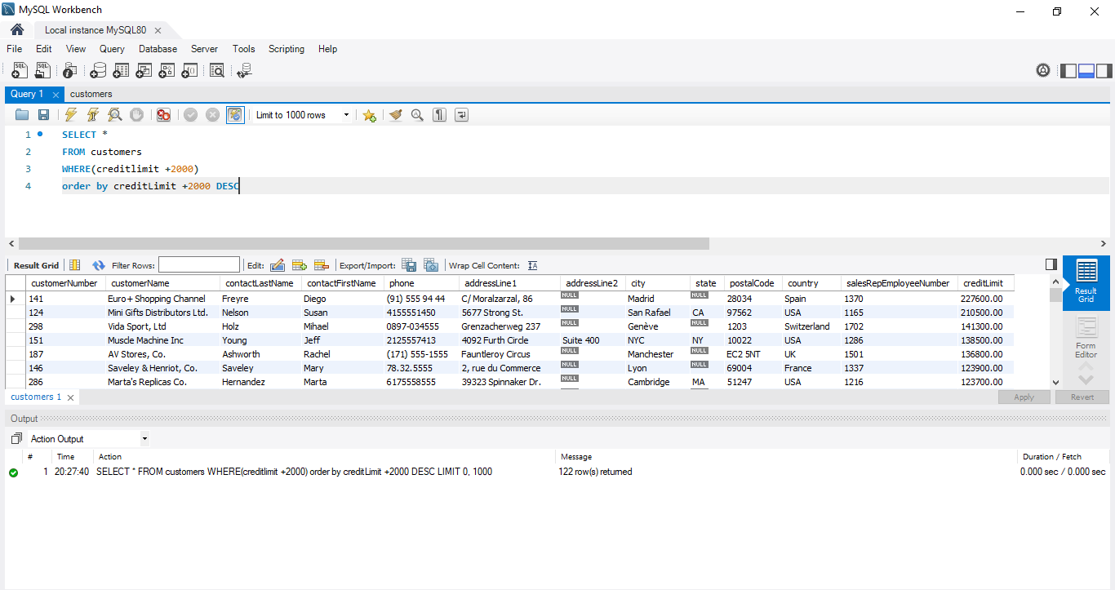Get all customers and calculate new_credit column (creditLimit + 2000) orders the query by new_credit DESC.

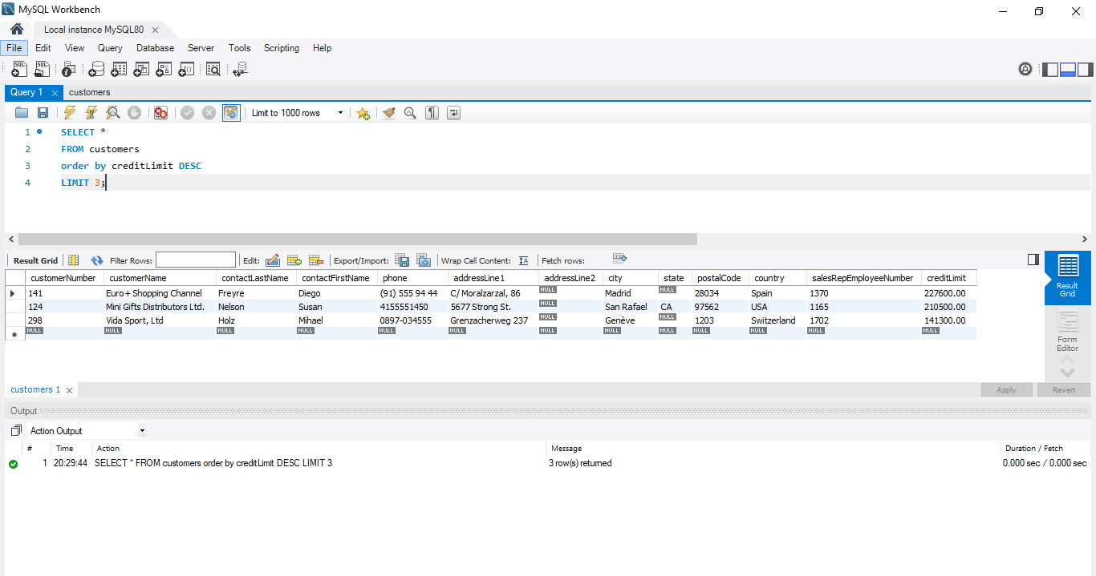Get 3 customers that have the highest creditLimit.